**The camera-system**

**Fundamental idea**

Our innovation tries to solve the problem of the collision with large animals. So first of all we want to notice these animals in their natural environment. It can be difficult for two reasons: first is, that we can meet them not only on roads, which goes through fields, but also on forest roads; the second is animals move likely at night. In both cases human vision is not able to notice animals, so the driver can’t react before the accident. The normal RGB cameras with AI can recognise objects in ideal urban circumstances, but they are not able to notice wild animals with natural camouflage, because they move fast, they are “invisible” for these cameras in a bushy forest or at night. The reflectors of the vehicle provide solution to see animals at night, but they light only the road up, so the approaching animals in the forest won’t be perceived. Our detection based on the thermal radiation. Large mammals (for example deer, roe, boar and also human) have a radiation in the near infrared interval (800 nm – 2500 nm), that is out of the visible spectrum (380 nm – 780 nm). With this type of radiation, animals can be perfectly “visible” for NIR-cameras. The other objects around animals have different thermal radiation, trees, bushes, other plants and the ground have lower temperature.

**Structure**

Our camera-system have two cameras. The cooperation of these cameras supports the the Bosch “Multi Purpose Camera”, which has 3 main functions. We can use the innovation for the “multipath approach” function. (“The benefits of this multipath approach are particularly apparent in real, complex traffic situations. The camera navigates by lines on the asphalt, by other characteristics indicative of a road surface, such as gravel, parked vehicles at the side of the road, and safety barriers. **With this, the reliability of automatic emergency braking systems increases, particularly in chaotic urban traffic, as the multi purpose camera can detect and classify partially obscured pedestrians and cyclists.**” - <https://www.bosch-mobility-solutions.com/en/solutions/camera/multi-purpose-camera/>)

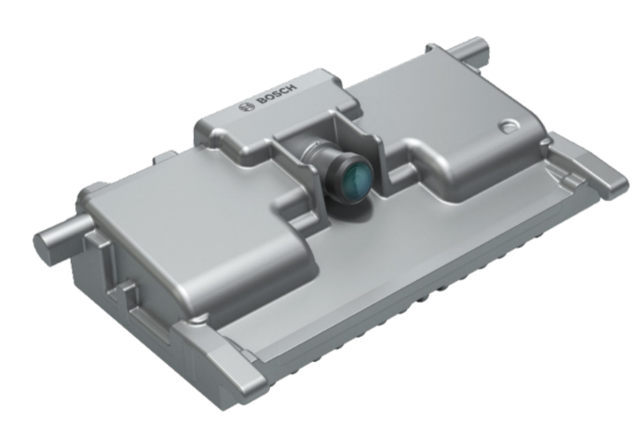Optics: Horizontal field of view: ±50°

Vertical field of view: 27°up, 21°down

Aperture: F1.8

Imager: Resolution: 2048 x 1280 pixels

Color pattern: RCCG

Frame rate: 45 fps

Mechanics: Box size: 120 x 61 x 36 mm

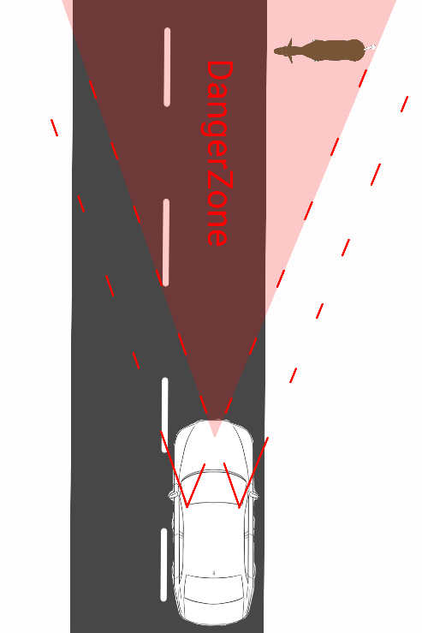**Measurement and field of view**

We would like to extend this multipath approach task to country roads to avoid the accident with animals. The two NIR-cameras must detect the large mammal on the road, at the side of the road or in the forest close to the road. The other important task of the NIR-cameras is to determine the distance and calculate the speed and direction of the noticed animal. Because of this second function, we must use 2 cameras to evolve this kind of 3D-vision.

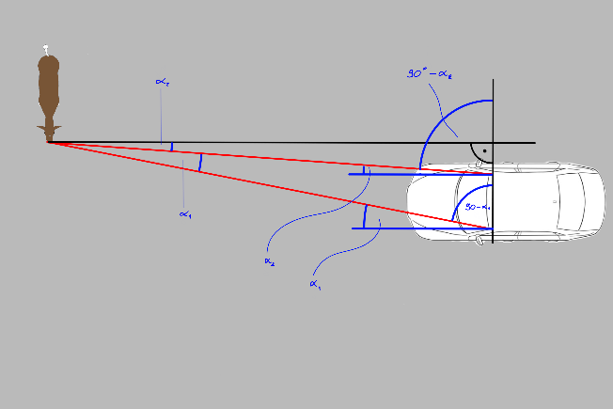The next figures and formulas show our method:

$$y=\frac{h}{\tan\left(α_{1}-α_{2}\right)}$$

$x=y ∙\tan\left(α_{2}\right)$

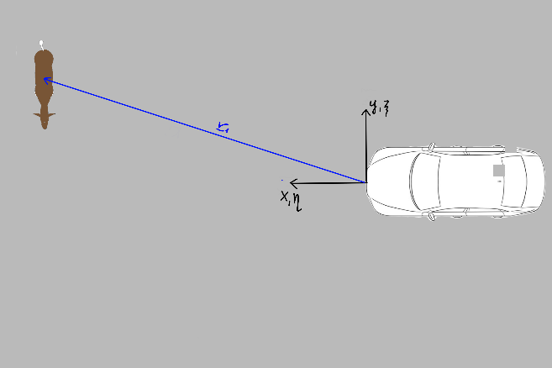Calculating the velocity of the animal:

$Δ{\vec{r}}_{\{ξ,η,ζ\}}={\vec{r}}_{2,\{ξ,η,ζ\}}-{\vec{r}}_{1,\{ξ,η,ζ\}}$

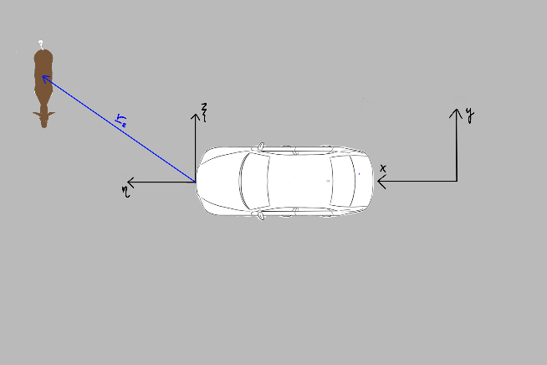 ${\vec{v}}_{rel}=\frac{Δ{\vec{r}}_{\left\{ξ,η,ζ\right\}}}{Δt}$

$${\vec{v}}_{\{x,y,z\}}={\vec{v}}_{rel}+{\vec{v}}_{car}+{\vec{ω}}_{car}×{\vec{r}}_{1,\{ξ,η,ζ\}}$$

The field of view of the cameras must be large enough, because the areas further from the side of the road are the most important for us to detect animals as soon as possible. The effective zone in distance and velocity measure is, where both cameras have detection area. The danger zone is the area from which animals running at full speed (approximately 50 km/h) perpendicular to the car (approximately 90 km/h) can crash into it. The angle of this area from the front of the car is $2∙\operatorname{atan}\left(\frac{v_{animal}}{v_{car}}\right)=60°$. The effective zone of view of the cameras has been chosen to match this angle.

**Optics**

An example to this type of NIR-lense: 3.5mm C Series VIS-NIR Fixed Focal Length Lens Field of view at max sensor format:

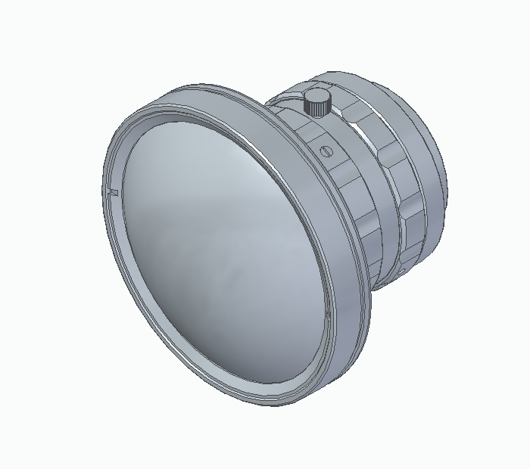Horizontal: 102,4°

Vertical: 82,3°

Size: 33 x 40 x 33 mm

**Detector**

We need a camera, that detects in NIR spectrum. It must have enough large resolution, sensing area and pixel depth with small pixel size to be able to provide sufficient information about the image. The camera is built onto a SoC (System on Chip) architecture. The chip performs preprocessing on the raw picture and compresses it to enable data transfer via the MOST interface (max. 150 Mbps). This way the whole camera has a compact design which saves space in the car and doesn’t disturb the drivers view. This quantity of data allows that the image processor (after a well set noise filtering) creates a sharp and accurate image about the objects of which thermal radiation is in the searched interval (so we concentrate on the animals).

**An example to this type of camera with the appropriate sensor:**

**Camera: Allied Vision 1800 U-501m NIR**

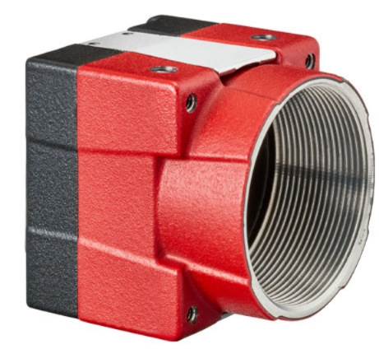Pixels (H x V): 2592 x 1944

Pixel Depth: 8/10 bit

Resolution: 5 (MegaPixels)

Pixel Size, H x V (µm): 2,2 x 2,2

Frame Rate: 68 fps

Operating Temperature: -30°C – 80°C

Size: 38 x 29 x 29 mm

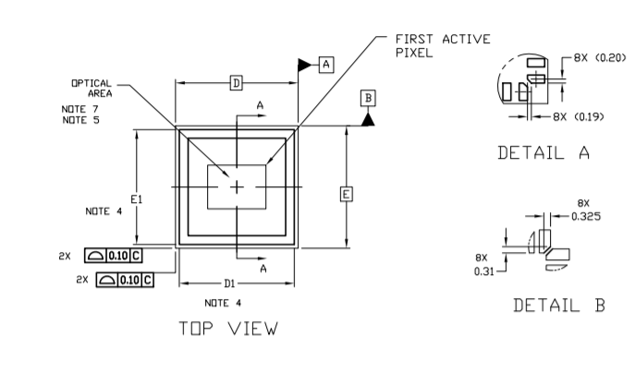**Imaging Sensor: ON Semi AR0522**

